SRS FOR ONLINE SHOPPING MART

**Abstract**

The Online Shopping System Software requirements Specification (SRS) report outlines the essential specifications and requirements needed to develop a dependable and user-friendly online shopping platform. In the current digital era, e-commerce has become an essential part of the retail environment. This SRS document offers the framework for creating an efficient and user-friendly online purchasing experience for both administrators and customers.

This project's main goal is to design, develop, and implement an online shopping system that satisfies the diverse demands of modern consumers. This system will offer a wide range of products, user-friendly interfaces, secure payment options, and efficient order management for clients. It will also give administrators access to comprehensive inventory, customer care and sales administration.

**Functional Requirements**

Functional requirements for an online shopping system define the specific features and functionalities that the system must provide to meet user and business needs. Here's a detailed breakdown of functional requirements for an online shopping system:

* Registration
* Product Search
* Shopping cart and Checkout
* Payment Process
* Order Management
* Return and Exchange
* Customer Support

**Non Functional Requirement**

Non-functional requirements for an online shopping system focus on qualities that are not directly related to specific functionalities but are critical for the overall success and effectiveness of the system. Here's a breakdown of non-functional requirements for an online shopping system

* Performance
* Security
* Usability
* Scalability
* Reliability
* Scalability

**MODULES DESCRIPTION**

**1.Registration**

Users should be able to register with the platform by providing necessary details such as name, email address, and password. If customer wants to buy the product then he/she must be registered, unregistered user can’t go to the shopping cart. Implement mechanisms for password recovery and account activation.

**2.Product search and Management**

Admins should be able to add, edit, and delete products. Each product should have attributes such as name, description, price, category, images, and stock quantity. Allow admins to organize products into categories and subcategories for easier navigation. Support for managing product variants. Allow users to browse and search for products easily.

**3.Shopping Cart and Checkout**

Allow users to add products to their shopping cart. Display the contents of the shopping cart, including product details, quantities, and total price. Allow users to update quantities, remove items, or clear the entire cart. Provide a secure checkout process with multiple steps for entering shipping address, selecting shipping method, and payment details.

**4.Payment Processing**

Integrate with one or more payment gateways to accept various payment methods such as credit/debit cards, PayPal, digital wallets and post paid after shipping. Ensure that payment processing is secure and compliant with industry standards.

**5.Order Management**

Admins should have access to a dashboard to view and manage orders.

Users should receive email notifications for order confirmation, shipment, and delivery. Allow users to track the status of their orders in real-time. Automatically update stock levels when orders are placed or cancelled. Notify admins when stock levels are low or out of stock.

**6.Returns and Exchanges**

The system should have a clear and user-friendly returns and exchange policy,

A dedicated page outlining the return and exchange policy with clear instructions

Easy process for initiating returns or exchanges online Clear communication regarding return shipping options and costs

**7.Customer Support**

Email support with a dedicated email address and response timeframes Live chat functionality for real-time assistance, Phone support with clear operating hours and

FAQ section with answers to common customer questions.

**Flowchart**

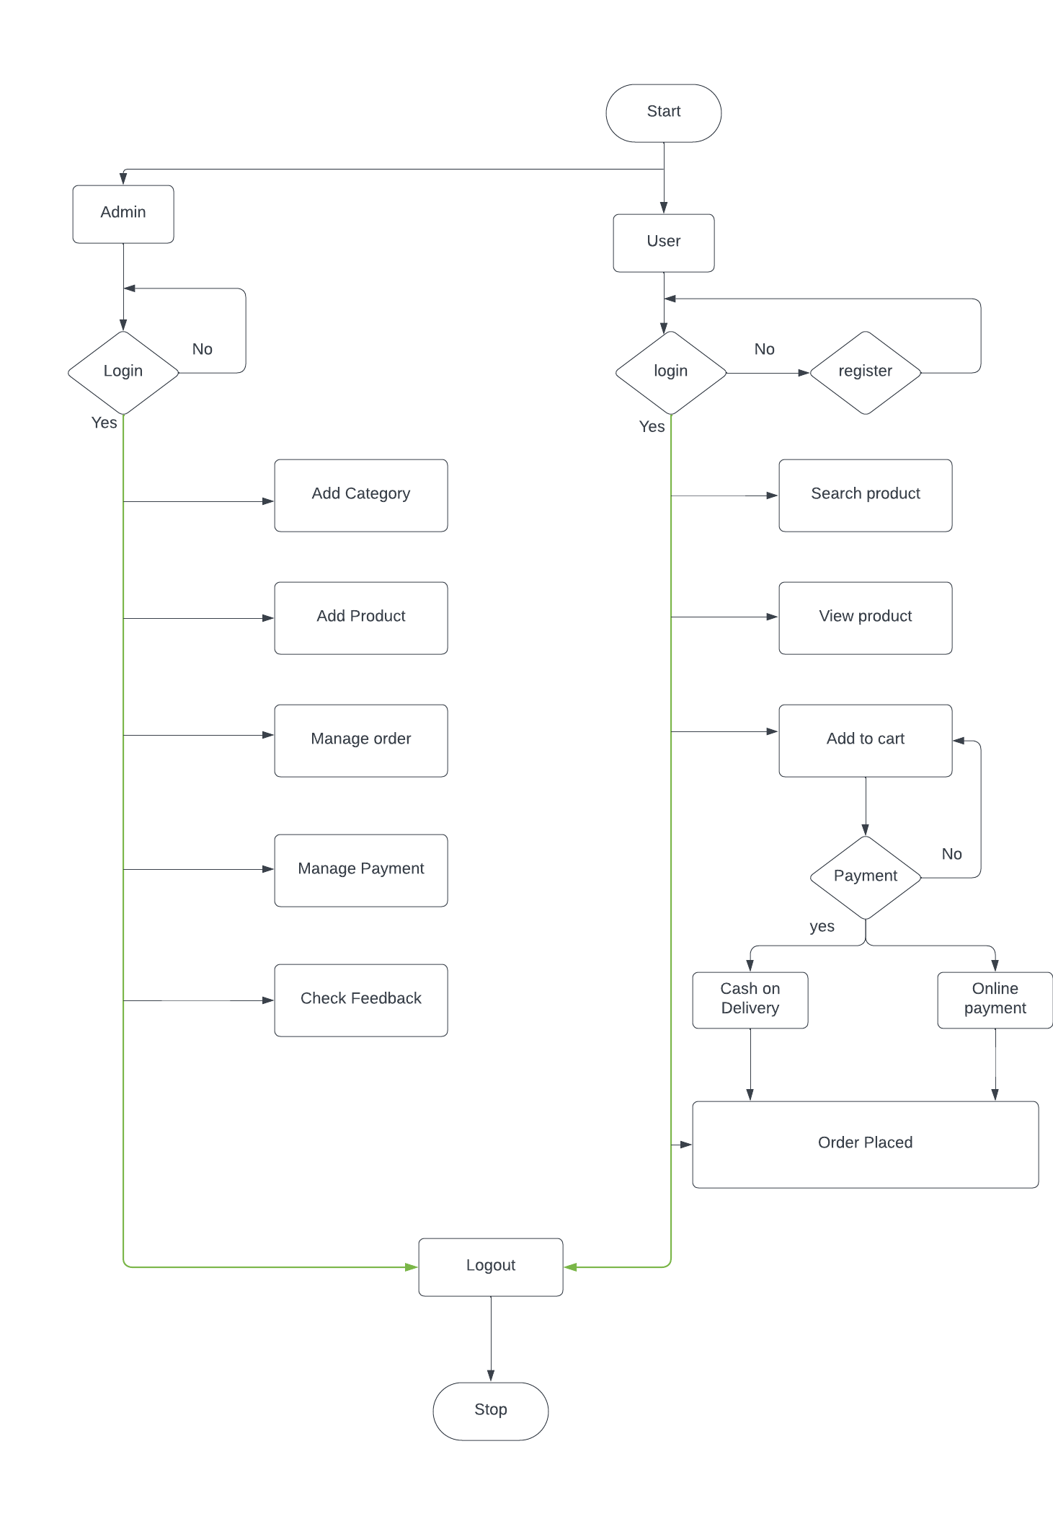

**Use case Diagram**

Use-case diagrams describe the high-level functions and scope of a system. These diagrams also identify the interactions between the system and its actors. The use cases and actors in use-case diagrams describe what the system does and how the actors use it, but not how the system operates internally. 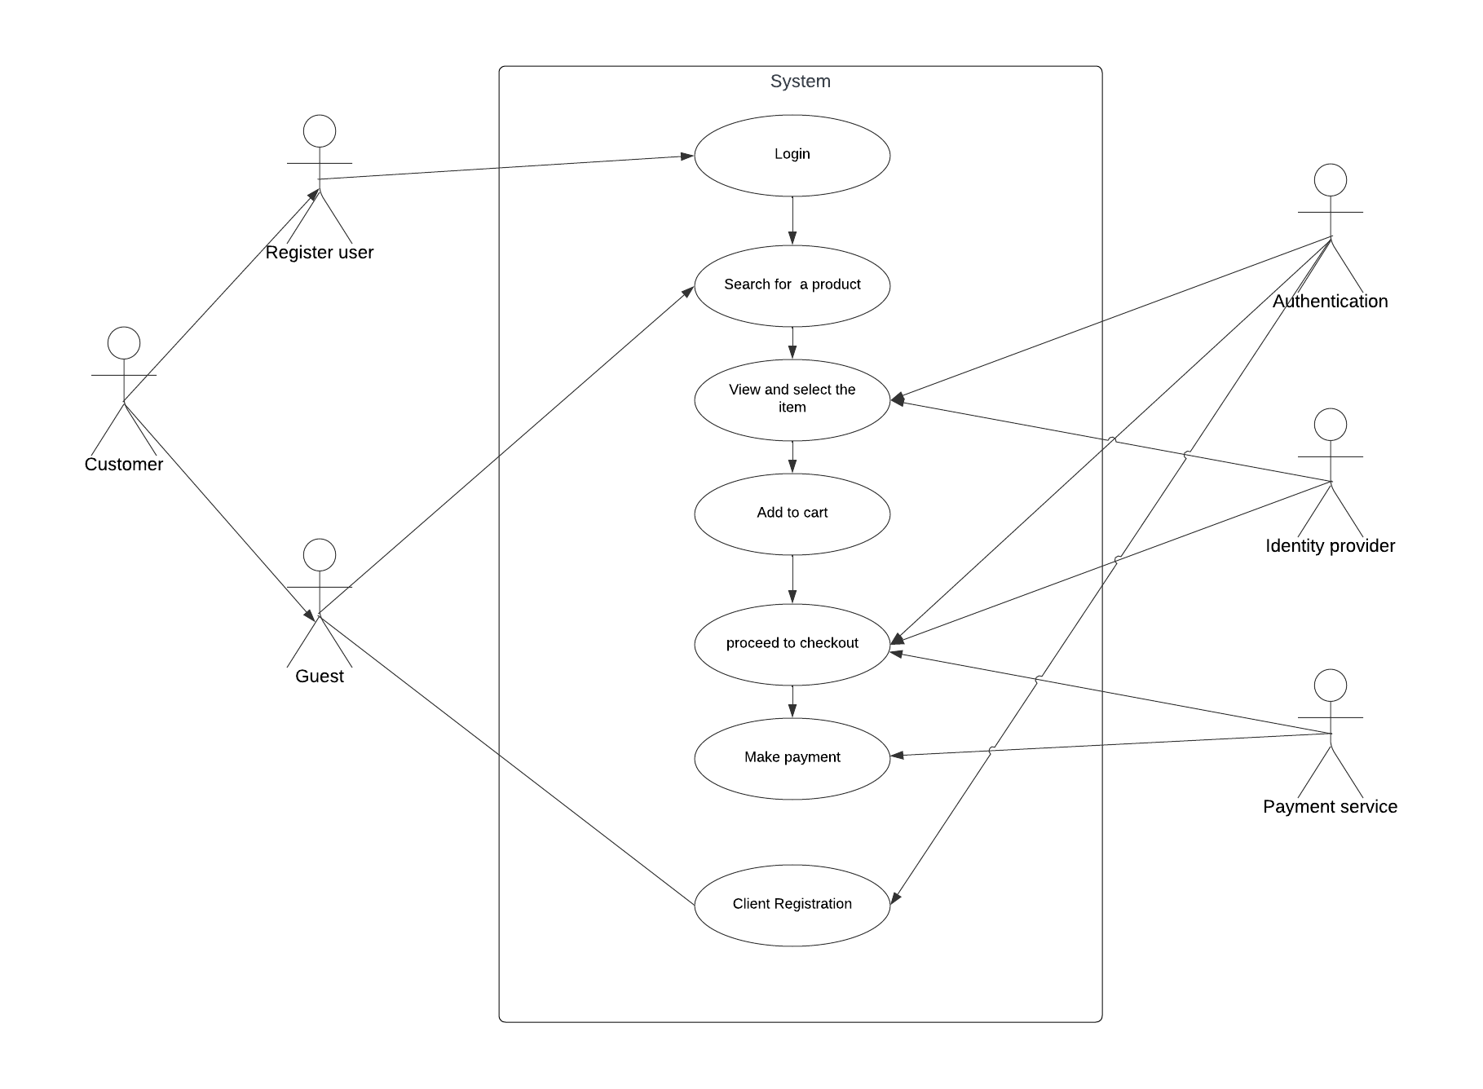

**Class Diagram**

Class diagrams are the blueprints of your system or subsystem. You can use class diagrams to model the objects that make up the system, to display the relationships between the objects, and to describe what those objects do and the services that they provide. Class diagrams are useful in many stages of system design.

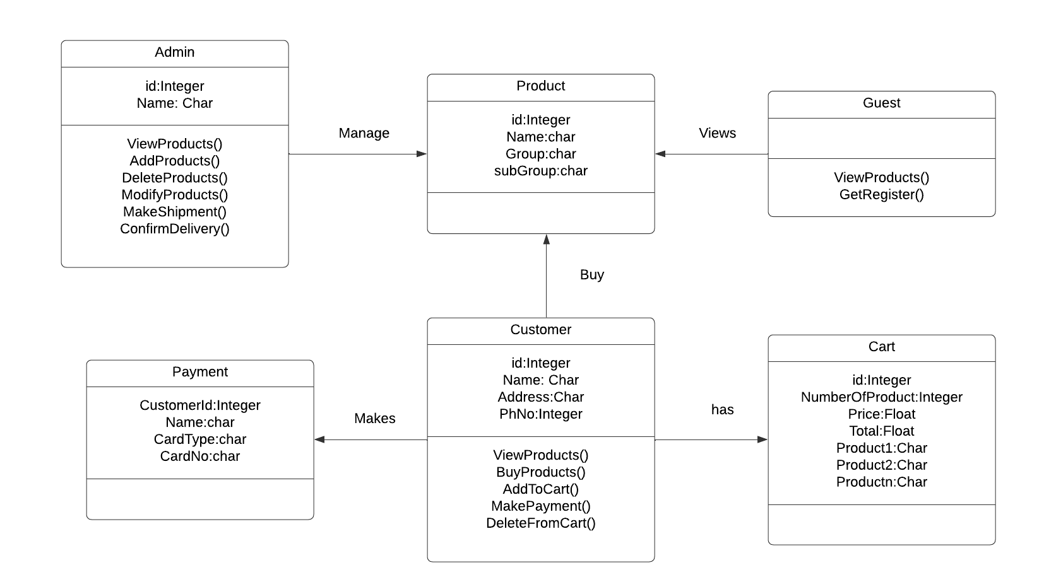

**Sequence Diagram**

A sequence diagram is a Unified Modeling Language (UML) diagram that illustrates the sequence of messages between objects in an interaction. A sequence diagram consists of a group of objects that are represented by lifelines, and the messages that they exchange over time during the interaction.

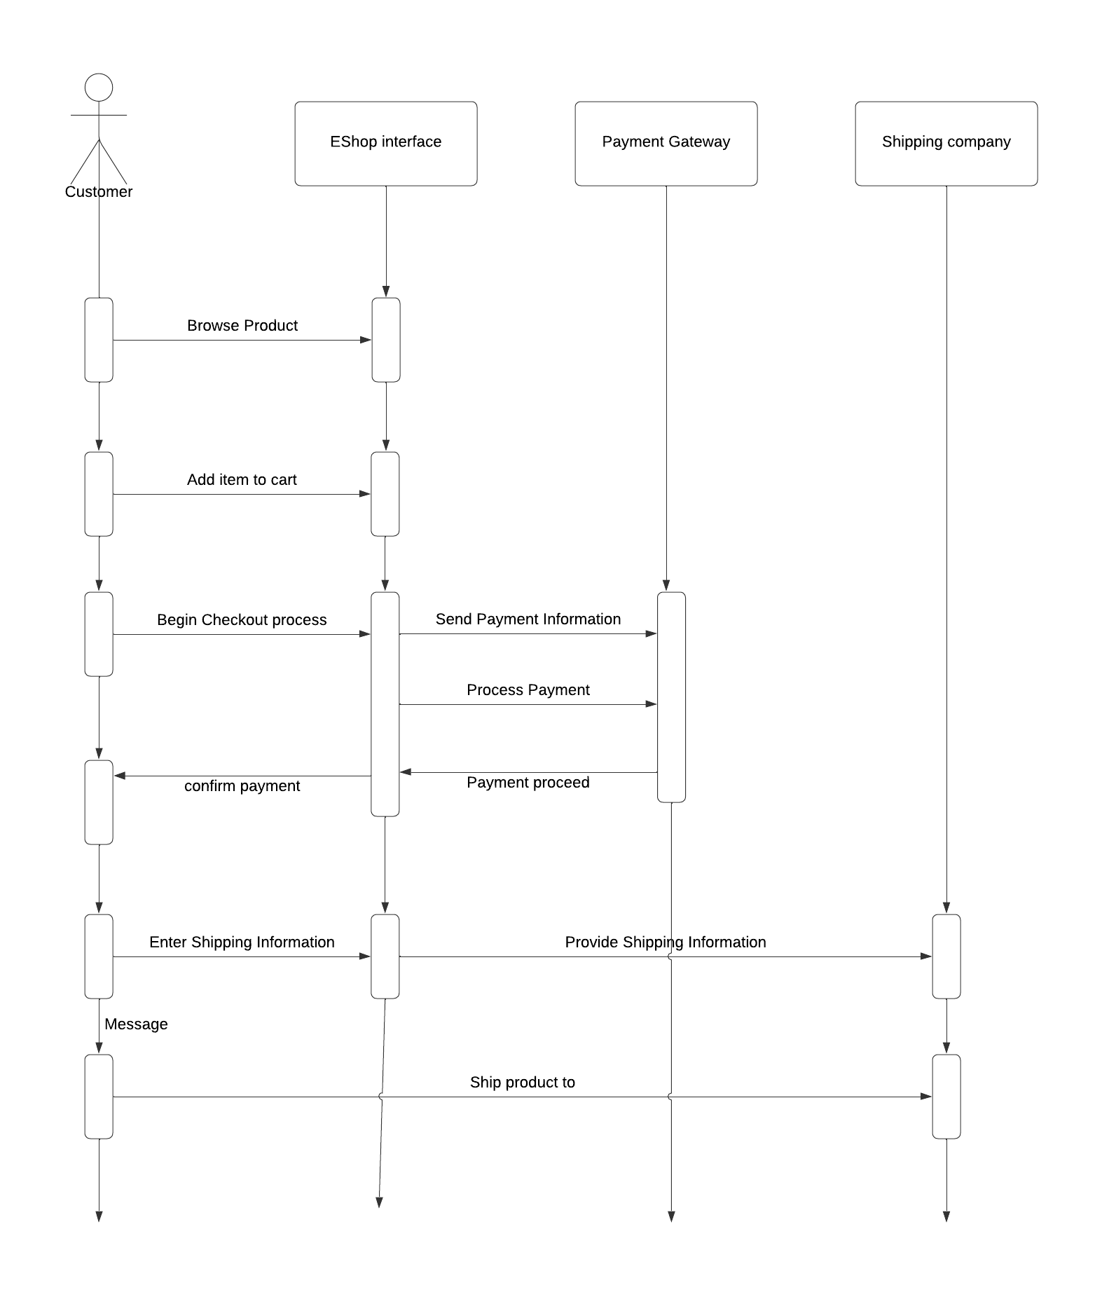

**Conclusion**

The Software Requirements Specification (SRS) for an online shopping system serves as a comprehensive document outlining the functional and non-functional requirements, as well as the overall design and scope of the system.